Plant Cell Colouring KEY
If plant is coloured according to the directions, it should look like this:
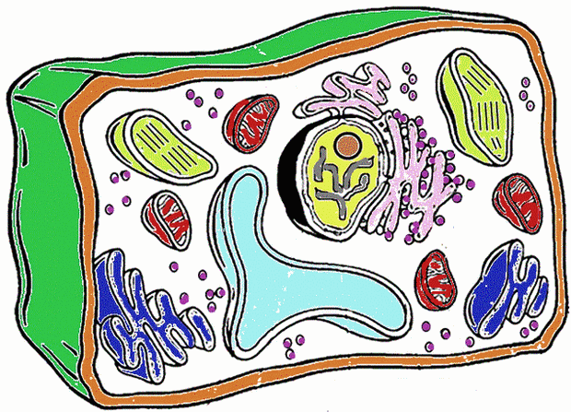
Analysis
1. Name two things found in a plant cell that are not found in an animal cell: vacuole, cell wall
2. How does the shape of a plant cell differ from that of an animal cell? square vs round
3. What is the function of the chloroplasts? photosynthesis
4. What is the function of the vacuole? stores water

